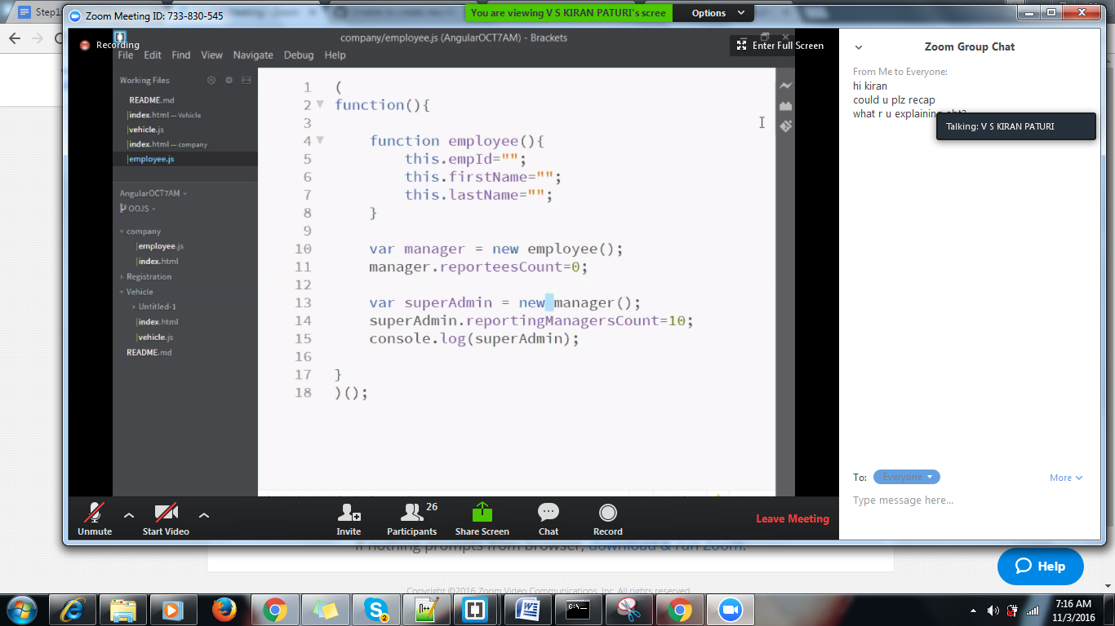

As new manager is not ba constructor,it hasn’t supported, as it is just an object so we have extended through by creating an object and extending by specfyng obj type manager.

3 properties got inherited

And 1 property has its by own

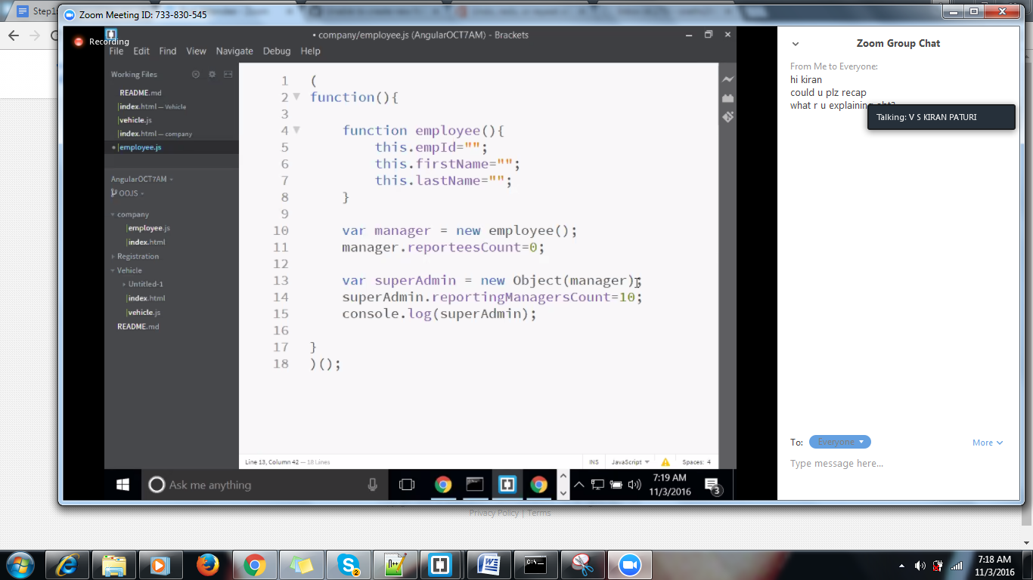 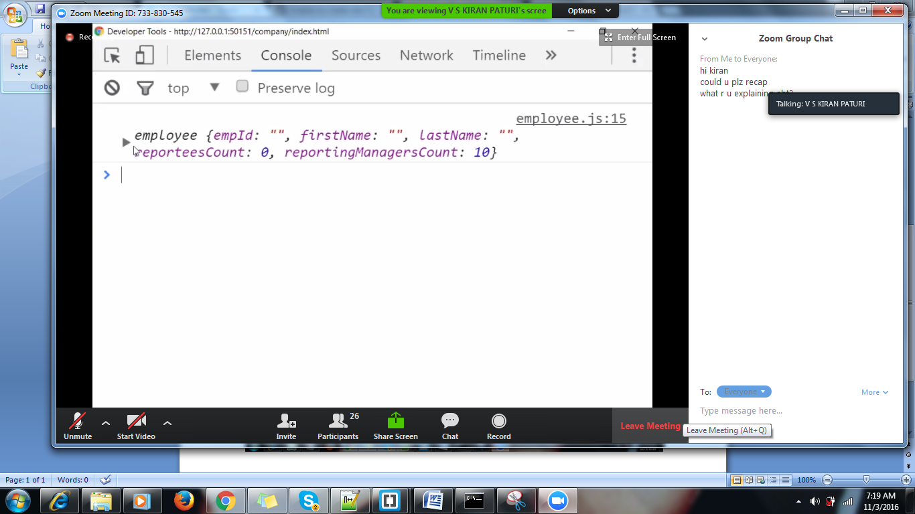

Every object is derived from a null obj.

In a case if we miss a Gender in the function,

We will doing using by prototype

Every obj in js will have a default prototype.

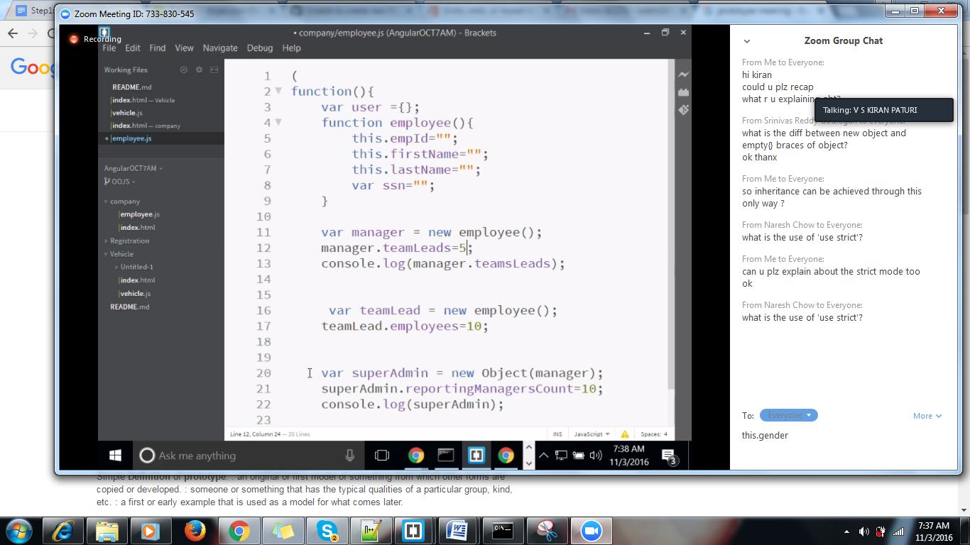

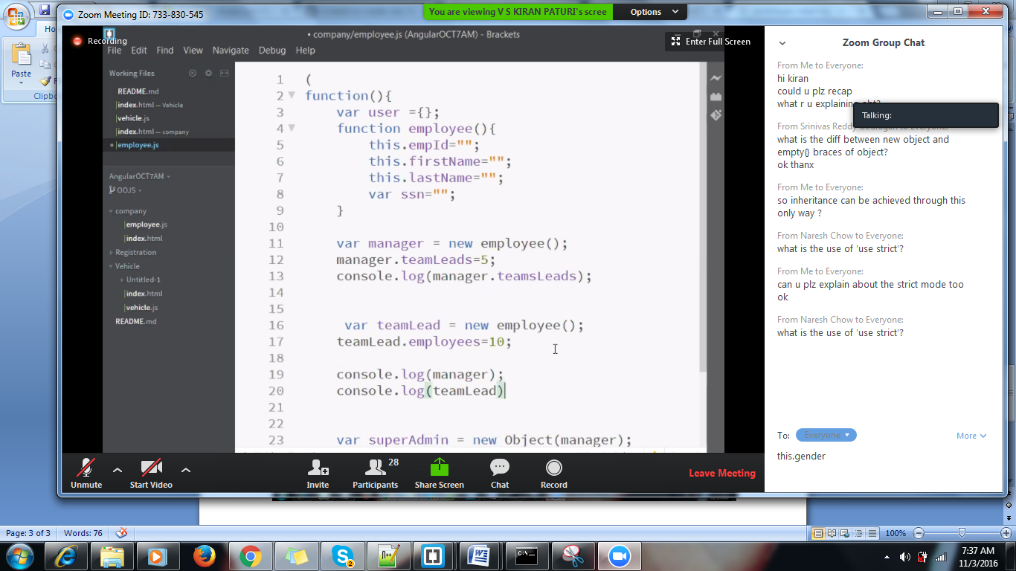

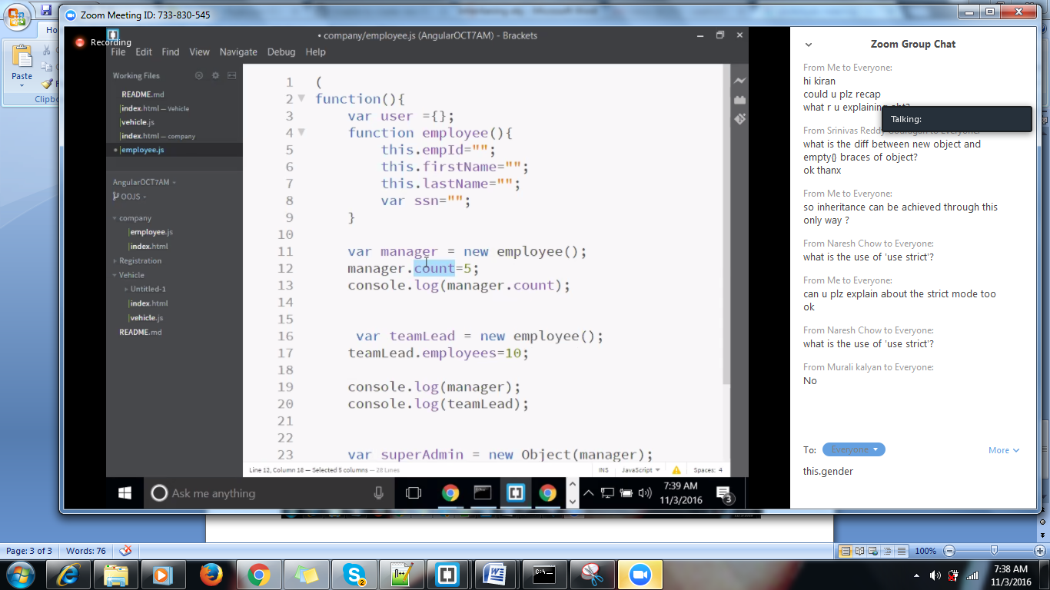

Comment superadmin here

After creation of object, we are able to attach a property to the parent class through prototype

employee.prototpe.gender=””;

classname.prop name =”Ind” // static prop as we don’t have instances.

Prototypal inheritance.

How to achieve static prop of a class?

Static prop will not be used in js, for version num generally will be used.

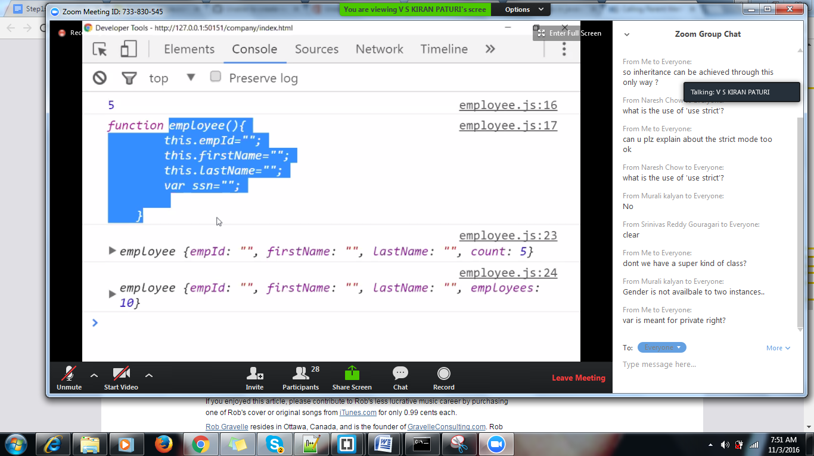

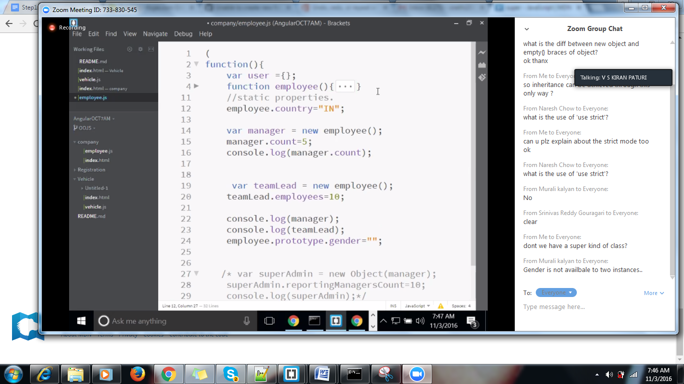

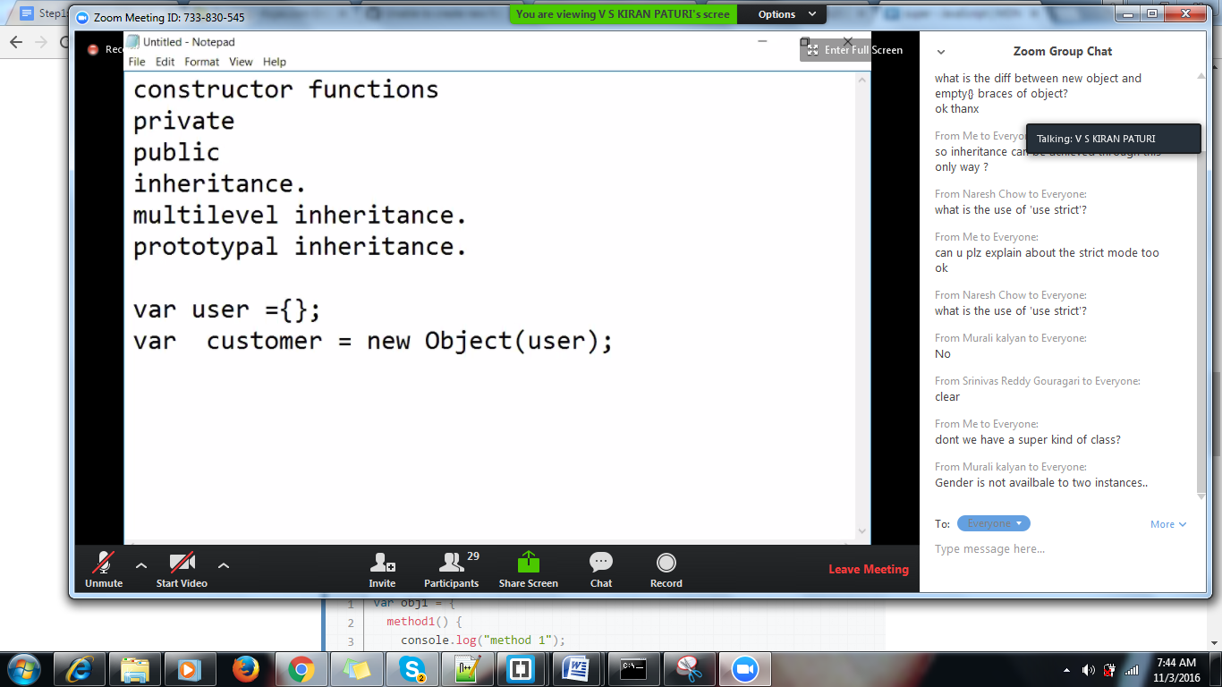

Static class

Static class don’t have instances.